**Color Segmentation**

1. **Model Selection**

First I selected regions of red barrels from the training images. After that I noticed that after transforming an image from RGB to HSV (Hue, Saturation, Value) color space, the red color corresponds to values of H below 5 or above 175. So that I implemented a simple classifier that thresholded the H component of a pixel with the aforementioned values. However, the results were poor (see Figure 1).

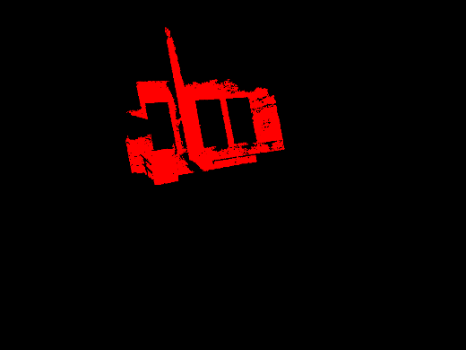

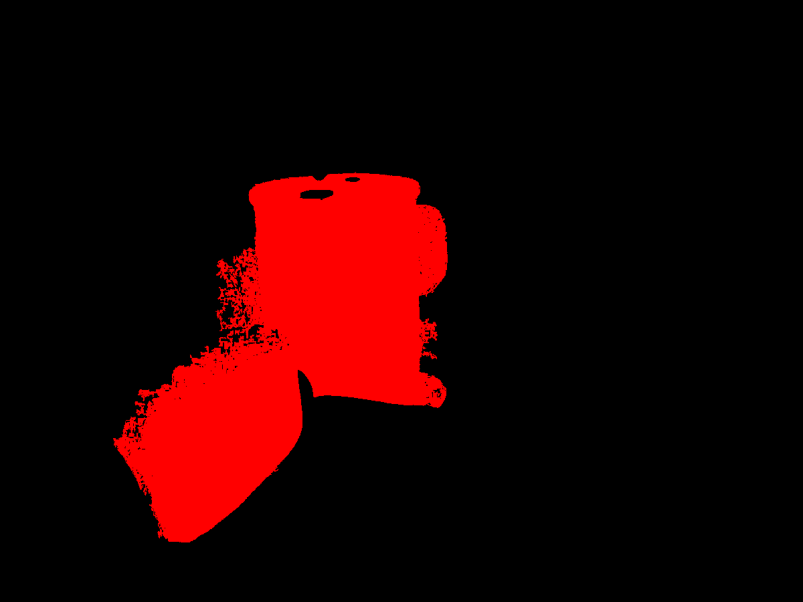

Figure 1. Errors of thresholding classifier by H component

Then I fitted the red and not red pixels from a training data with multivariate Gaussian distributions. The probability of a pixel belonging to a red class was calculated via Bayes formula and chain rule. I calculated the prior as an average ratio of red (or not red) to other pixels in the image. This approach resulted in slightly better segmentation of objects containing red color, but still it was not perfect (see Figure 2).

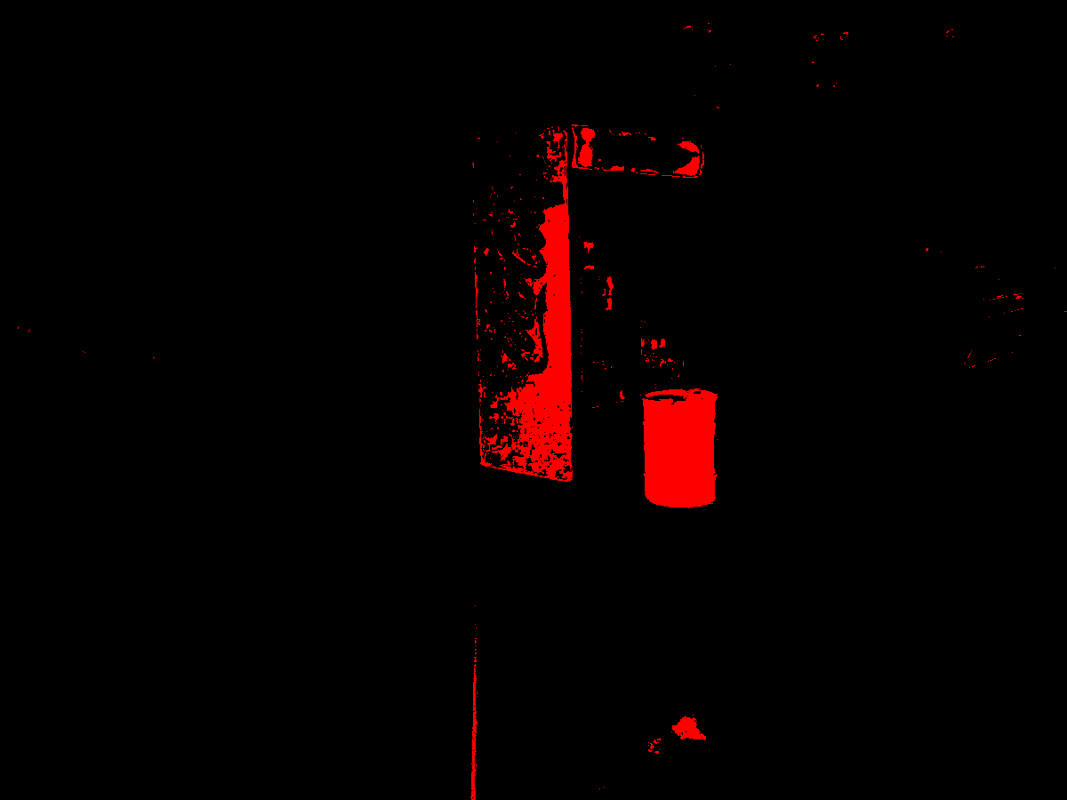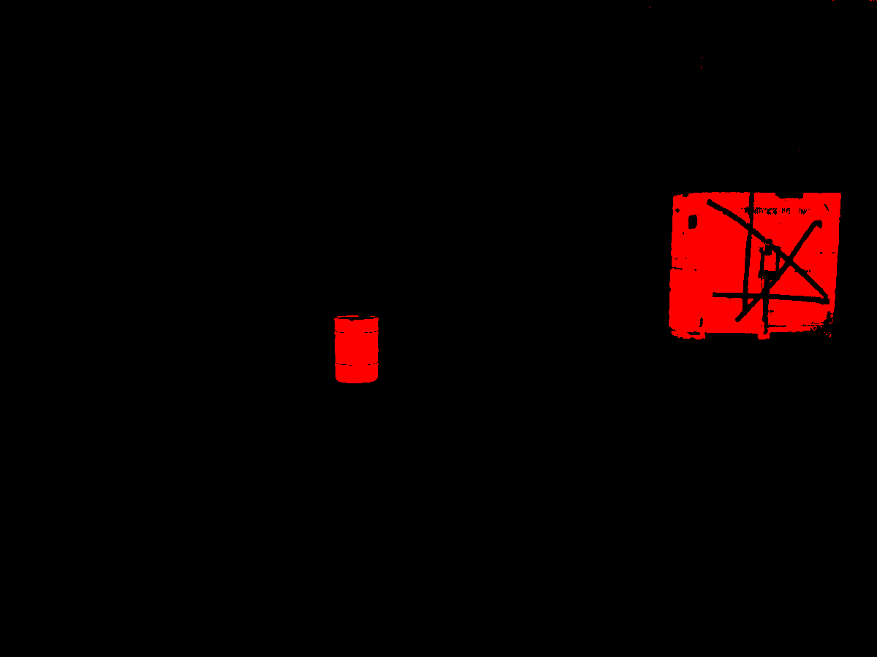

Figure 2. Errors of Gaussian model classifier applied to HSV image

Then I tried to use another color space – YcbCr which consists of of one luminance component (Y), and two chrominance components (Cb and Cr). The same process of fitting Gaussian distributions was performed and as a result the performance of an algorithm was increased, but it still had hard times detecting barrels when the was another object of distinctive red color on the image (and especially behind the barrel) – see Fugure 3.

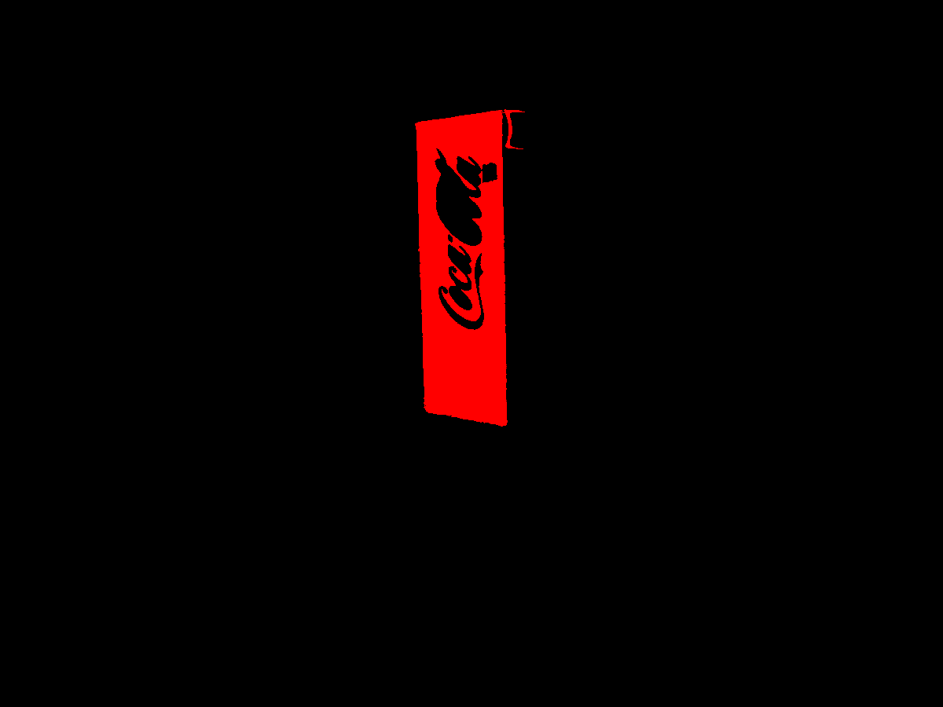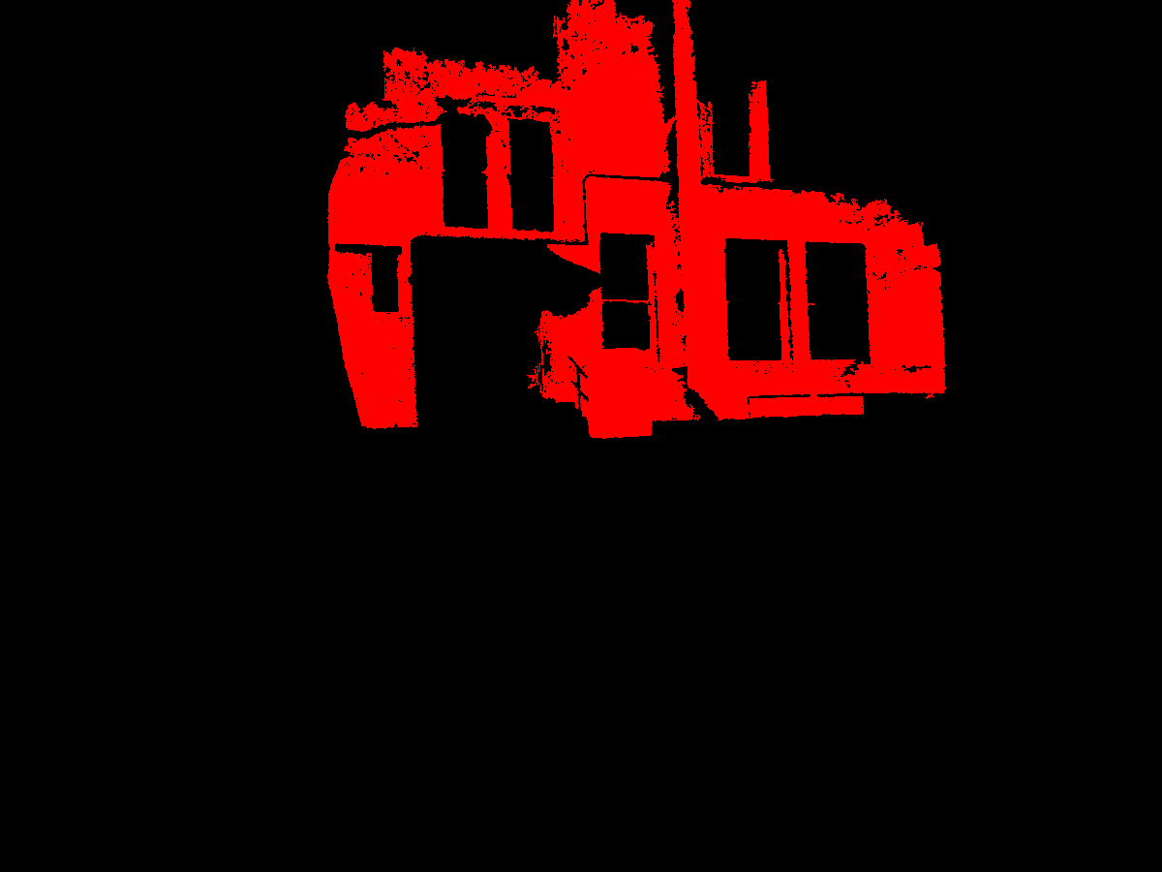

Figure 3. Errors of Gaussian model classifier applied to YcbCr image

In order to overcome the aforementioned problem I added another label to the training set – almost_red. It contained red objects that were not barrels. This time I fitted three Gaussian distributions and as a result the performance of the algorithm significantly improved (see Figure 4).

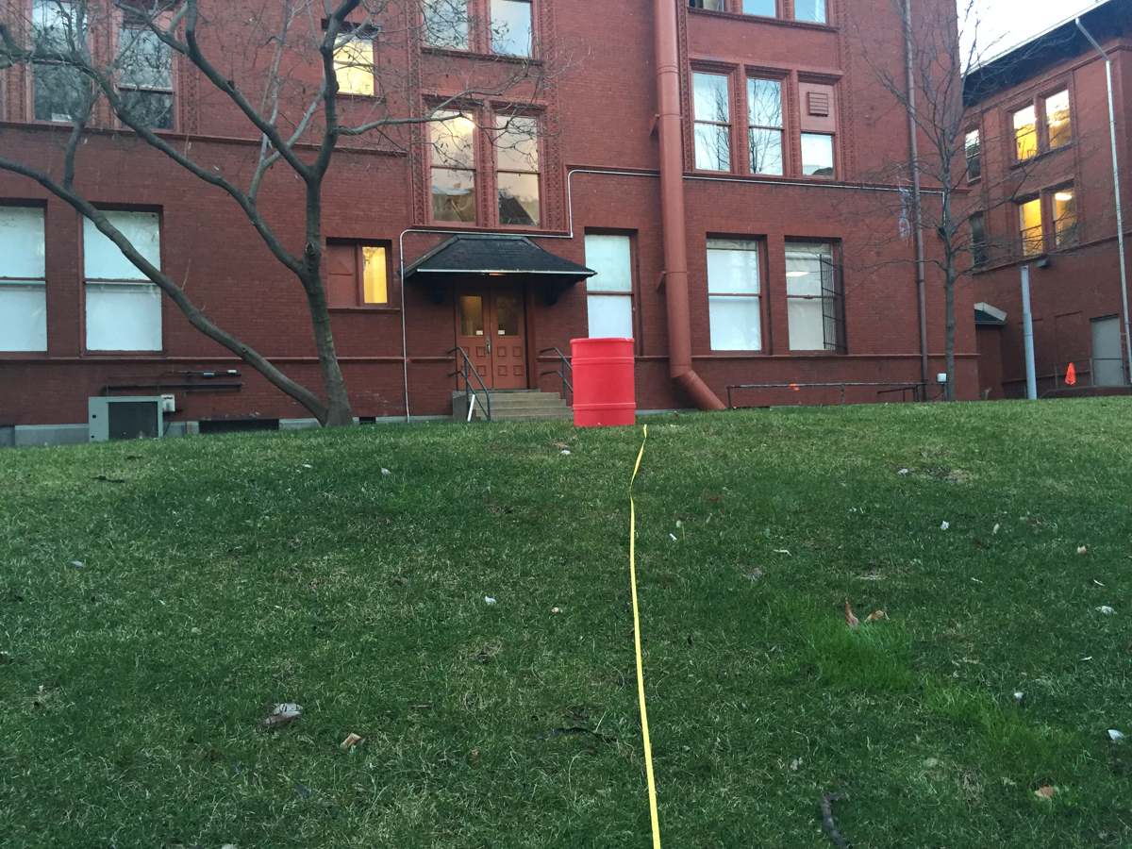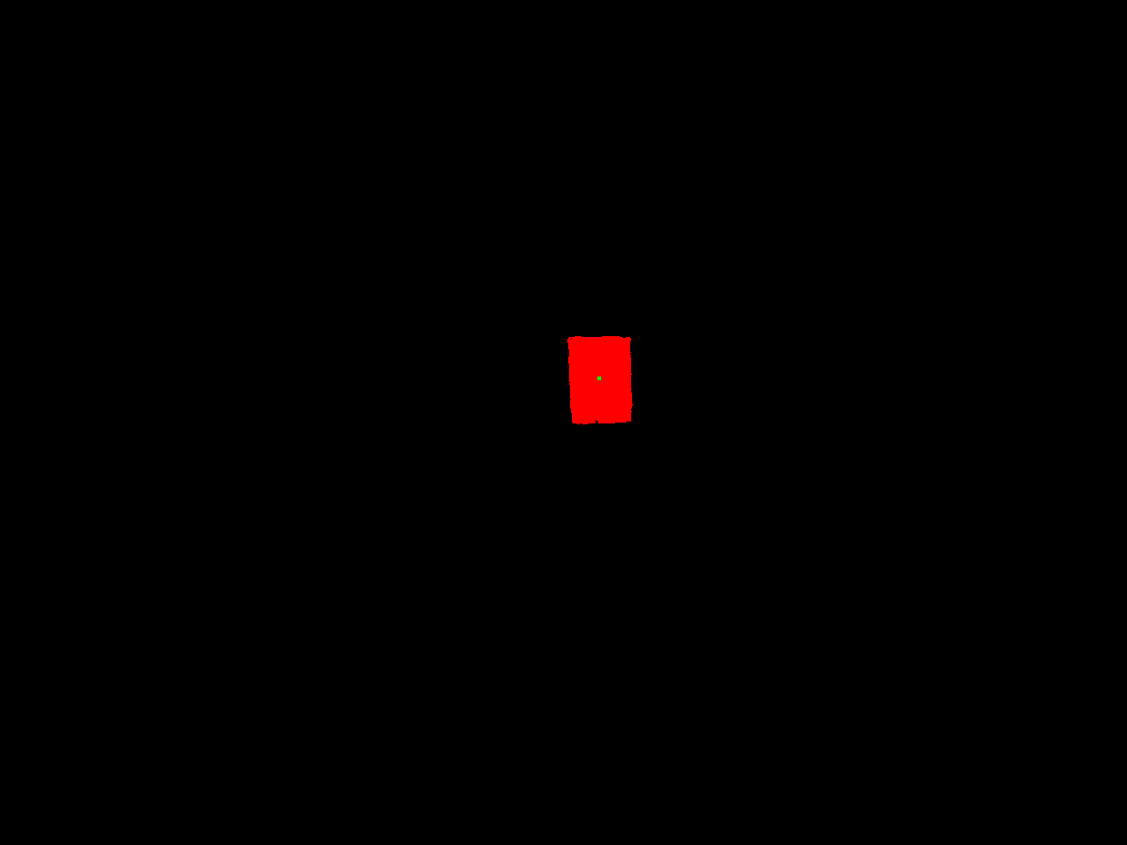

Figure 4. Difficult test case result after introduction of “almost_red” class

1. **Localizing the barrel**

Next step was to create a bounding box for barrel, compute coordinates of its center and measure the distance to the barrel.

First I had to select out of different red regions on the image the sector where the barrel was located. I used regionprops method from skimage library in order to obtain all the regions of red in the image. Then I iterated through each region and checked whether that region has the proportions of a barrel (major to minor axes ratio is between 1.3 and 3). The largest region that had these proportions was considered as barrel.

After that I used the findContours function from opencv library in order to get the contour of the barrel which then were used to draw a bounding box around the barrel. The coordinates of a center were calculated as a mean of a first and third coordinates of the bounding box.

In order to measure the distance to barrel I used a linear regression model that fitted the pixels area of barrels from training set to the distance that was contained in the name of training files. As with the change of distance, the pixels area on the image decreases in square root terms, I also included this parameter (sqrt(pixels_ares)) to the model. The fitted model can be seen on the Figure 5.

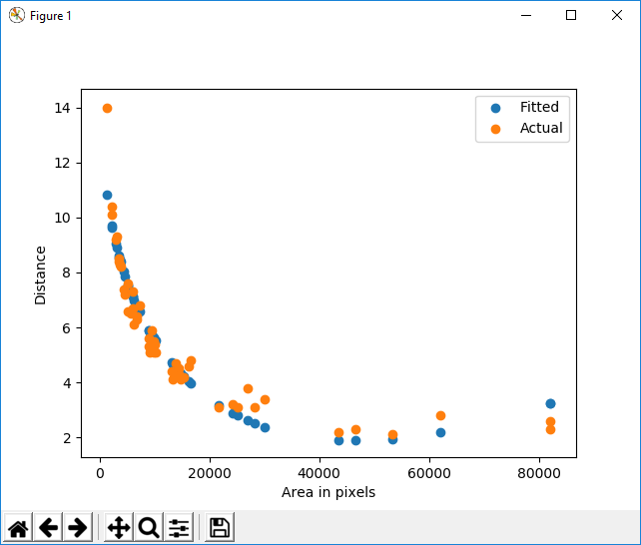

Figure 5. Distance model

On Figure 6 you can see the results the algorithm produced after applying aforementioned procedures:

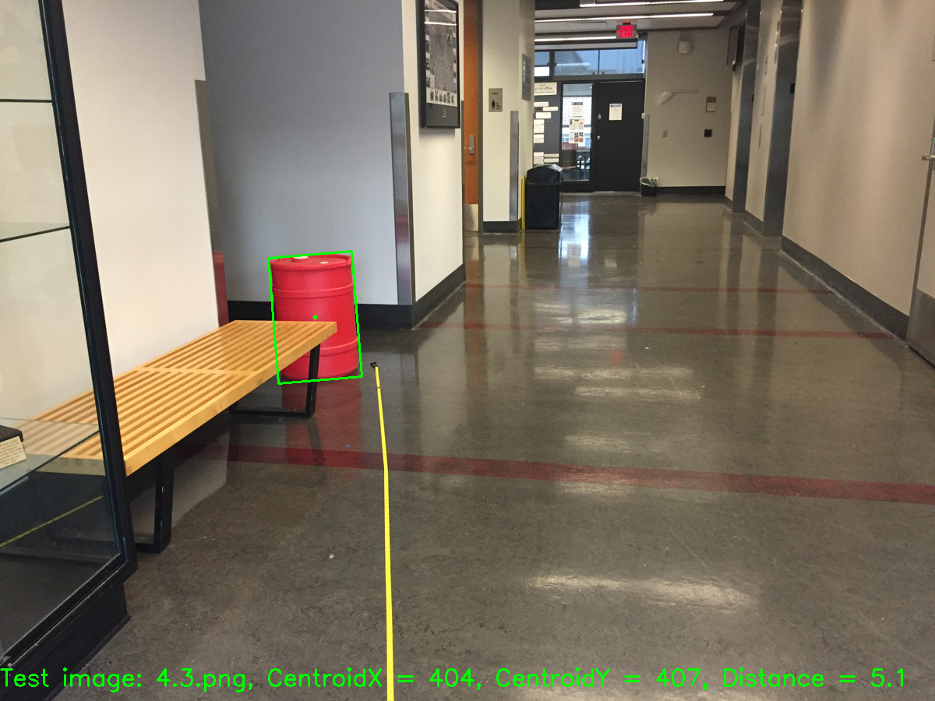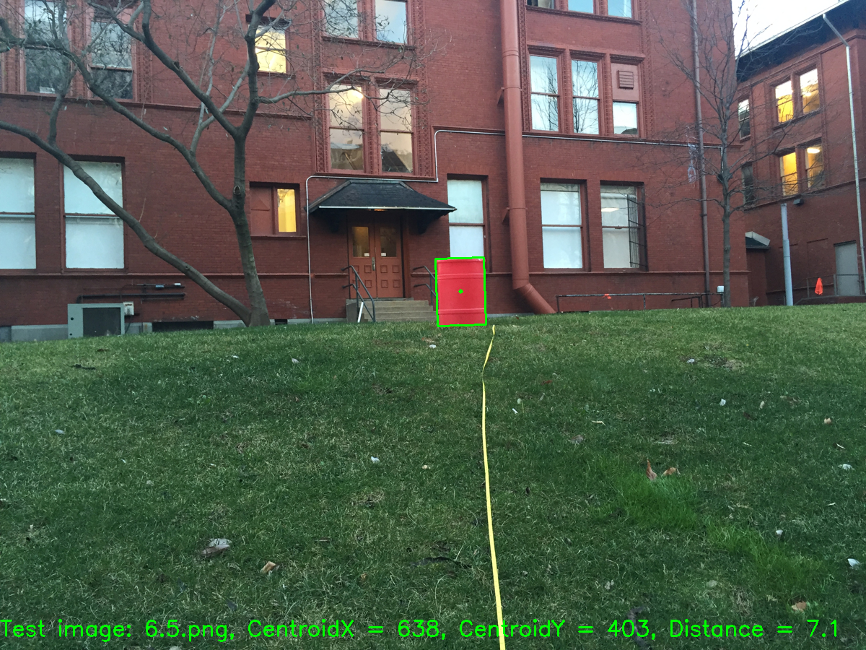

Figure 6. Final results

1. **Code files description**

File labeling.py was used to crop the regions of interest from the training data via roipoly.py library. The selected regions were saved to folders labeled_data_[class]. Regions in folder barrels were used to calculate the distance function.

File create_train_matrices.py was used to transform selected regions into YCrCb format and for every class all the pixels were stacked into a matrix with 3 columns containing 3 color components for each pixel. Also here I calculated the priors based on relative region area and calculated the distance function (linear regression model was used). All these files were saved as [class]_pixels.npy, [class]_priors.npy and distance_model.sav.

File detection.py is the file that is used to display final results. It utilizes the predict.py file where all the logic described in paragraph 2 (Localizing the barrel) is implemented.

1. **Test results**

As you can see from the test results in the end of this document, the developed algorithm performed pretty well as it was able to detect a barrel when there are other red objects in the picture and when it was partially occluded.

However, there are some drawbacks in performance as well which are summarized in the table below along with potential solutions.

|  |  |
| --- | --- |
| **Problem** | **Potential Solution** |
| Partial barrel detection due to intersection of both barrel’s diagonals by some object. | Search not for one region of red, but for several regions that have appropriate height to width ratio. |
| Detecting just one barrel when there are two of them on the image. |
| Under-detection due to dark lighting conditions. | Fit mixture of gaussians instead of single gaussian can help better catch both bright and dark patterns of red color. |
| Noisy distance estimation. | Use area of bounding box instead of total area of detected red pixels as a parameter to linear regression distance model. |

